**Initialize a Volume Restored from a Snapshot on Linux**

This section will guide you to:

* Initialize a volume restored from a snapshot

This lab has three subsections, namely:

3.10.1 Selecting the snapshot

3.10.2 Restoring volume from the snapshot

3.10.3 Pushing the files to GitHub repositories

**Step 3.10.1:** Selecting the snapshot

* Go to EC2 dashboard in EBS and click on *Snapshot*

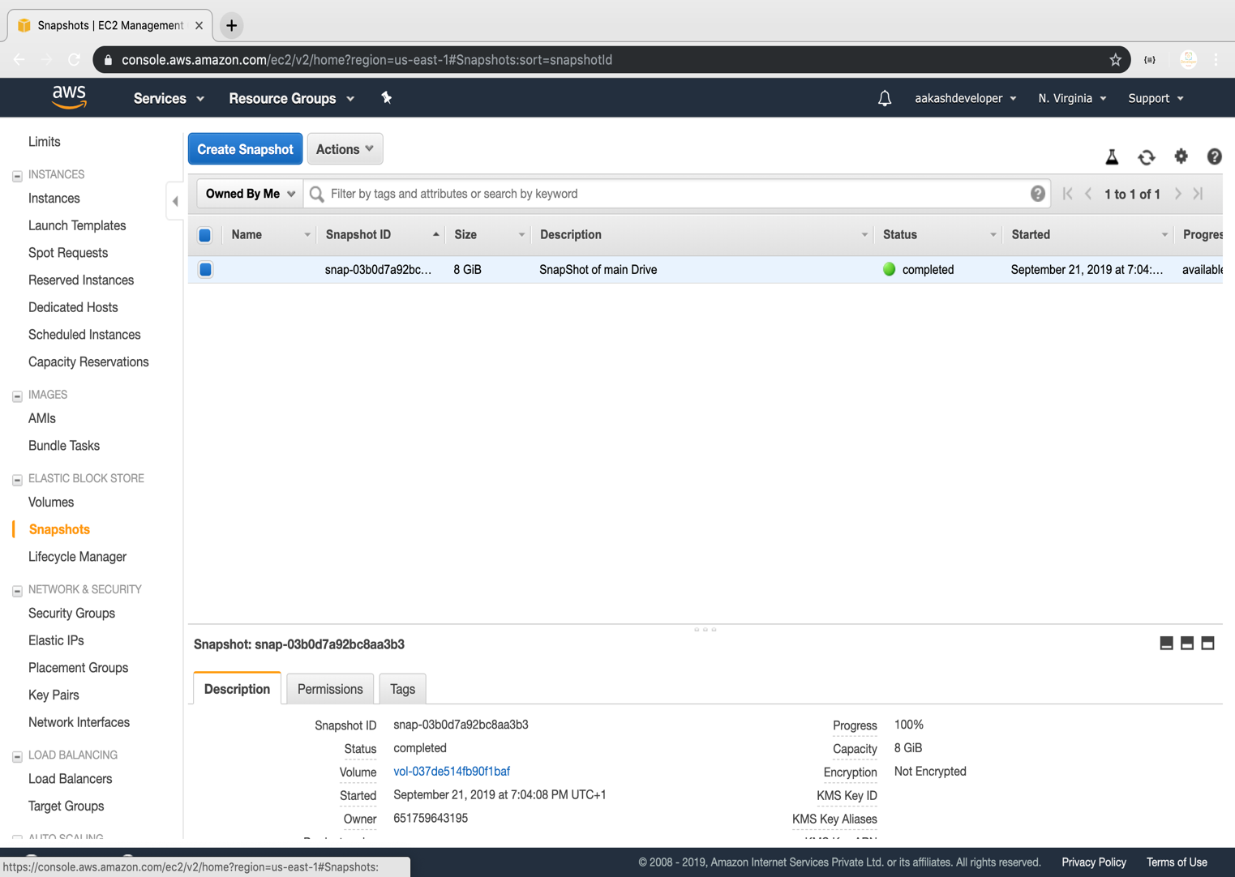

**Step 3.10.2:** Restoring volume from the snapshot

* Select the snapshot and click on *Action*

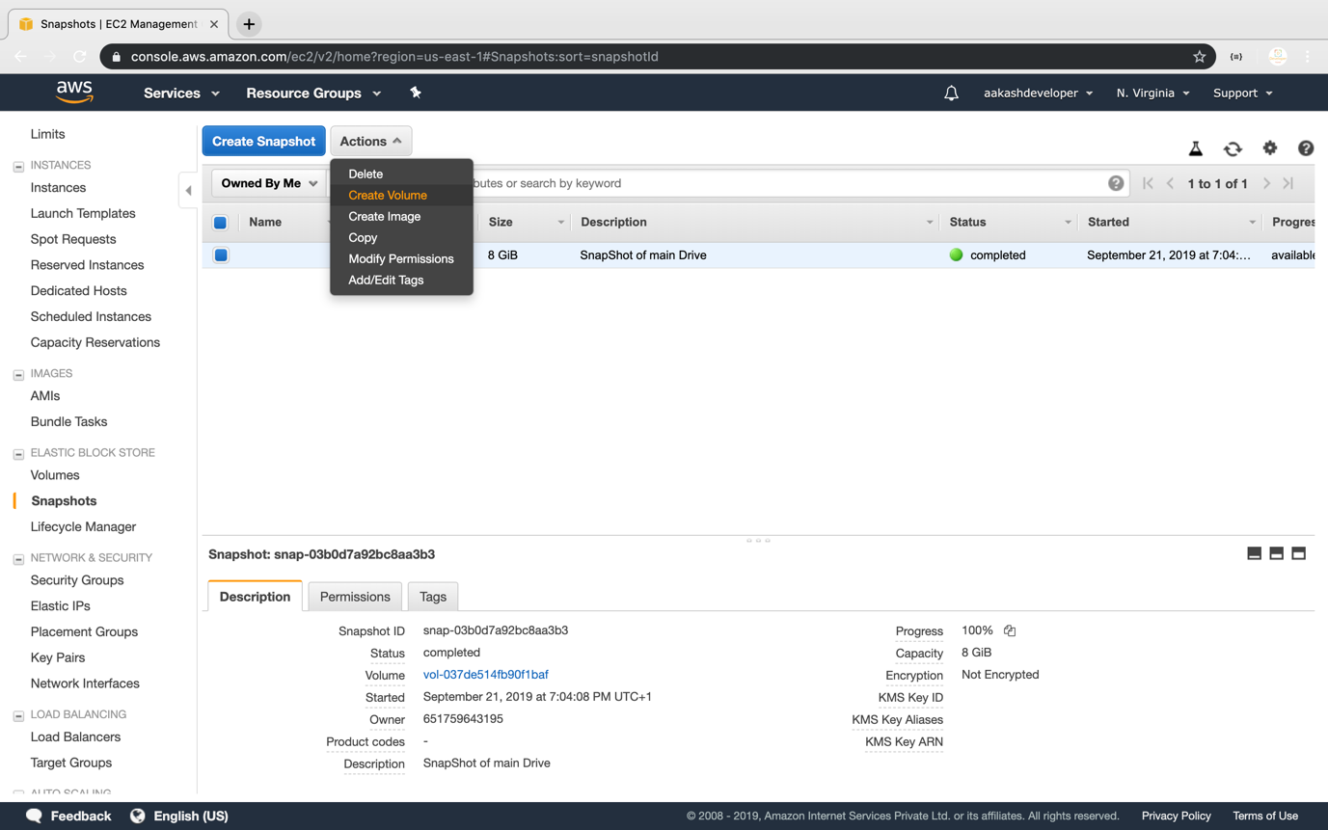

* You can specify the key and value to identify the volume

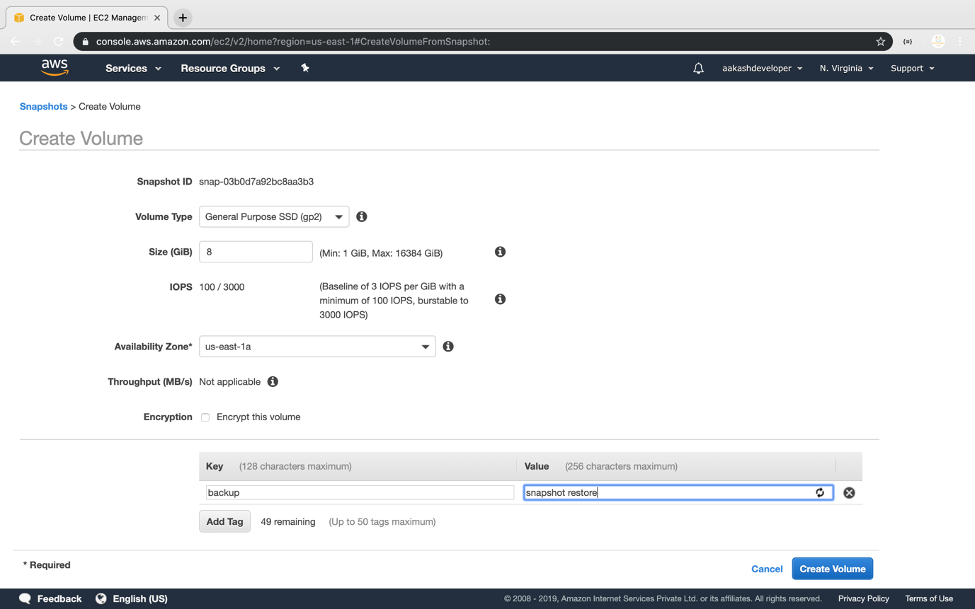

* Restore the volume from the snapshot

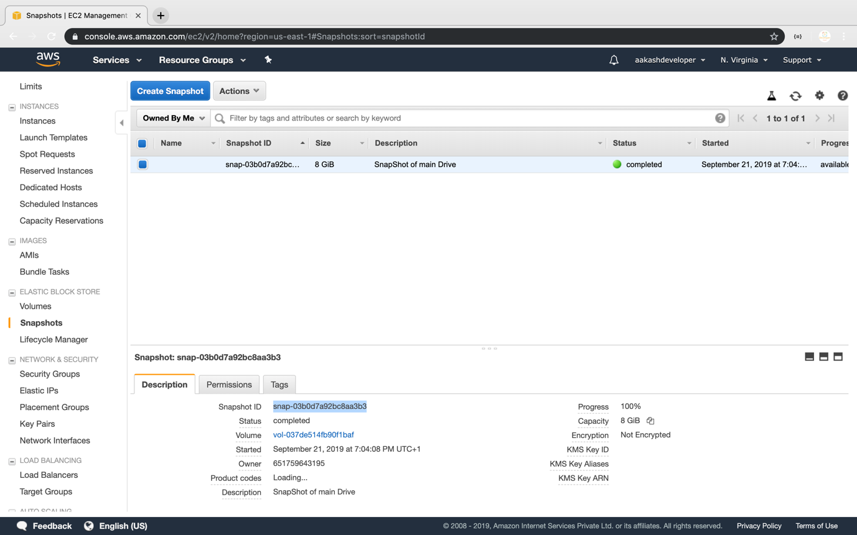

**Step 3.10.3:** Pushing the code to your GitHub repositories

* Open your command prompt and navigate to the folder where you have created your files.

**cd <folder path>**

* Initialize your repository using the following command:

**git init**

* Add all the files to your git repository using the following command:

**git add .**

* Commit the changes using the following command:

**git commit . -m “Changes have been committed.”**

* Push the files to the folder you initially created using the following command:

**git push -u origin master**